SLIDING WINDOW

Table of Contents
Theory 2
2. Variable-Size Window 3
3. Substring/Anagram Matching 3
4. Advanced Sliding Window 3
LEVEL 1: Fixed-Size Window 4
1. Maximum Average Subarray 4
2. First negative in every window of size k 4
3. Sliding Window Maximum 4
4. Count Occurrences of Anagrams 4
LEVEL 2: Variable-Size Window 5
1. Longest Subarray with Sum K 5
2. Max Consecutive Ones III 5
3. Longest substring without repeating characters 5
4. Longest Repeating Character Replacement 5
5. Fruits into baskets 5
LEVEL 3: Advanced Sliding Window 6
1. Binary subarray with sum 6
2. Count Subarrays With Score Less Than K 6
6. Number of Substrings Containing All Three Characters 7
SOLUTIONS: 8
LEVEL 1: 8
LEVEL 2: 14

Theory

Think of sliding window as looking at a moving segment (window) of an array or string.
Instead of checking every possible subarray/substring separately (which is slow, O(n^2)), we reuse information from the previous window when sliding forward.
- Fixed Sliding Window: Keep a window of fixed size k, compute its value (sum/avg/etc.), and as the window slides, remove the element going out and add the element coming in in O(1) time.
- Variable Sliding Window: Expand the window step by step until the condition is satisfied, then shrink from the left while keeping the condition valid, ensuring the smallest/largest valid window is tracked
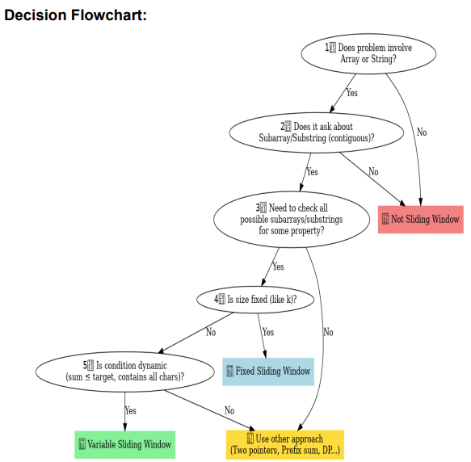

When to use Sliding Window:
- Sequential input (array/string) → contiguous part matters.
- Range-based question (sum, max, min, avg, count).
- Contiguity constraint (subarray/substring/continuous segment).
- Fixed size window (e.g., subarray of size k).
- Variable size window (expand/shrink until condition holds).
Can combine section 4-5
Section 7 and 10 in other places
Solutions are not descriptive now, add images and text.

2. Variable-Size Window — Longest Valid Window
This is the classic expand right → violate condition → shrink left → keep the longest valid window pattern.
- 3 — Longest Substring Without Repeating Characters — 🟡 Medium — LeetCode
- 159 — Longest Substring with At Most Two Distinct Characters — 🟡 Medium — LeetCode
- 340 — Longest Substring with At Most K Distinct Characters — 🟡 Medium — LeetCode
- 904 — Fruit Into Baskets — 🟡 Medium — LeetCode
- 1004 — Max Consecutive Ones III — 🟡 Medium — LeetCode
- 424 — Longest Repeating Character Replacement — 🟡 Medium — LeetCode
- 1208 — Get Equal Substrings Within Budget — 🟡 Medium — LeetCode
- 1493 — Longest Subarray of 1's After Deleting One Element — 🟡 Medium — LeetCode
- 2024 — Maximize the Confusion of an Exam — 🟡 Medium — LeetCode
- 1695 — Maximum Erasure Value — 🟡 Medium — LeetCode
- 2958 — Length of Longest Subarray With at Most K Frequency — 🟡 Medium — LeetCode
- 2401 — Longest Nice Subarray — 🟡 Medium — LeetCode

GFG supplements
- Longest Substring with K Unique Characters — 🟡 Medium — GFG
- Longest Substring Without Repeating Characters — 🟡 Medium — GFG

3. Variable-Size Window — Minimum / Shortest Valid Window
Here the objective is the opposite: expand until valid, then shrink as much as possible.
- 209 — Minimum Size Subarray Sum — 🟡 Medium — LeetCode
- 713 — Subarray Product Less Than K — 🟡 Medium — LeetCode
- 1658 — Minimum Operations to Reduce X to Zero — 🟡 Medium — LeetCode
- 1151 — Minimum Swaps to Group All 1's Together — 🟡 Medium — LeetCode
- 2134 — Minimum Swaps to Group All 1's Together II — 🟡 Medium — LeetCode
- 1888 — Minimum Number of Flips to Make the Binary String Alternating — 🟡 Medium — LeetCode
- 76 — Minimum Window Substring — 🔴 Hard — LeetCode

GFG supplements
- Minimum Size Subarray Sum — 🟡 Medium — GFG
- Smallest Window with All — 🔴 Hard — GFG

4. Frequency-Map Sliding Window
These problems require maintaining character/value frequencies inside the current window.
- 1876 — Substrings of Size Three with Distinct Characters — 🟢 Easy — LeetCode
- 3 — Longest Substring Without Repeating Characters — 🟡 Medium — LeetCode
- 159 — Longest Substring with At Most Two Distinct Characters — 🟡 Medium — LeetCode
- 340 — Longest Substring with At Most K Distinct Characters — 🟡 Medium — LeetCode
- 424 — Longest Repeating Character Replacement — 🟡 Medium — LeetCode
- 2958 — Length of Longest Subarray With at Most K Frequency — 🟡 Medium — LeetCode
- 2743 — Count Substrings Without Repeating Character — 🟡 Medium — LeetCode
- 2799 — Count Complete Subarrays in an Array — 🟡 Medium — LeetCode
- 2962 — Count Subarrays Where Max Element Appears at Least K Times — 🟡 Medium — LeetCode

GFG supplements
- Longest Substring with K Unique Characters — 🟡 Medium — GFG
- Count Occurrences of Anagrams — 🟡 Medium — GFG

5. Anagram & Permutation Sliding Window
This is one of the most important fixed-frequency window patterns for string interviews.
- 567 — Permutation in String — 🟡 Medium — LeetCode
- 438 — Find All Anagrams in a String — 🟡 Medium — LeetCode
- 187 — Repeated DNA Sequences — 🟡 Medium — LeetCode
- 1461 — Check If a String Contains All Binary Codes of Size K — 🟡 Medium — LeetCode
- 2156 — Find Substring With Given Hash Value — 🟡 Medium — LeetCode
- 30 — Substring with Concatenation of All Words — 🔴 Hard — LeetCode
The common idea here is to keep a fixed-size or word-sized window and efficiently update the frequency/state as the window moves. LeetCode community pattern collections repeatedly group 438, 567 and 30 together under Sliding Window/string-window problems.

6. At-Most-K / Exactly-K Sliding Window
This is a very important interview pattern:
Exactly K = At Most K − At Most (K − 1)
- 930 — Binary Subarrays With Sum — 🟡 Medium — LeetCode
- 1248 — Count Number of Nice Subarrays — 🟡 Medium — LeetCode
- 1358 — Number of Substrings Containing All Three Characters — 🟡 Medium — LeetCode
- 795 — Number of Subarrays with Bounded Maximum — 🟡 Medium — LeetCode
- 2799 — Count Complete Subarrays in an Array — 🟡 Medium — LeetCode
- 2537 — Count the Number of Good Subarrays — 🟡 Medium — LeetCode
- 2743 — Count Substrings Without Repeating Character — 🟡 Medium — LeetCode
- 992 — Subarrays with K Different Integers — 🔴 Hard — LeetCode
This family is one of the standard Sliding Window templates, particularly for counting subarrays/substrings rather than simply finding one longest window.

GFG supplements
- Longest Substring with K Unique Characters — 🟡 Medium — GFG
- Count Subarrays with Exactly K Distinct Elements — 🟡 Medium — GFG

8. Sliding Window + Deque / Window Maximum-Minimum
This is the advanced window-extrema pattern. Learn the basic window first, then learn how a deque keeps only useful candidates.
- 220 — Contains Duplicate III — 🟡 Medium — LeetCode
- 1438 — Longest Continuous Subarray With Absolute Diff Less Than or Equal to Limit — 🟡 Medium — LeetCode
- 2762 — Continuous Subarrays — 🟡 Medium — LeetCode
- 239 — Sliding Window Maximum — 🔴 Hard — LeetCode
- 480 — Sliding Window Median — 🔴 Hard — LeetCode
239 is the key problem for mastering monotonic deque-based window processing: the window moves one position at a time while the deque removes expired and dominated elements.

GFG supplements
- Maximum of All Subarrays of Size K — 🟡 Medium — GFG
- Maximum of All Subarrays of Size K — Sliding Window Maximum — 🟡 Medium — GFG

9. Circular / Special Sliding Window Problems
These are important because they force you to recognize that the window may need to behave as if the array were circular or the valid region needs special handling.
- 1652 — Defuse the Bomb — 🟢 Easy — LeetCode
- 1151 — Minimum Swaps to Group All 1's Together — 🟡 Medium — LeetCode
- 2134 — Minimum Swaps to Group All 1's Together II — 🟡 Medium — LeetCode
- 1423 — Maximum Points You Can Obtain from Cards — 🟡 Medium — LeetCode
- 1888 — Minimum Number of Flips to Make the Binary String Alternating — 🟡 Medium — LeetCode
For this section, the important skill is understanding window movement over a duplicated/circular representation rather than treating the input as an ordinary linear array.

10. Advanced Sliding Window String Problems
These are the problems I would use after mastering the standard templates.
- 1208 — Get Equal Substrings Within Budget — 🟡 Medium — LeetCode
- 1297 — Maximum Number of Occurrences of a Substring — 🟡 Medium — LeetCode
- 2024 — Maximize the Confusion of an Exam — 🟡 Medium — LeetCode
- 2156 — Find Substring With Given Hash Value — 🟡 Medium — LeetCode
- 2953 — Count Complete Substrings — 🔴 Hard — LeetCode
- 3305 — Count of Substrings Containing Every Vowel and K Consonants I — 🟡 Medium — LeetCode
- 3306 — Count of Substrings Containing Every Vowel and K Consonants II — 🔴 Hard — LeetCode

LEVEL 1: Fixed-Size Window
Use this pattern when the window length is exactly K. Track a running sum/count as the window moves one position at a time. This is the fundamental Sliding Window pattern

Maximum Average Subarray (643)
Link: https://leetcode.com/problems/maximum-average-subarray-i/
- Number of Sub-arrays of Size K and Average Greater than or Equal to Threshold (1343)

Maximum Number of Vowels in a Substring of Given Length (1456)
Link: https://leetcode.com/problems/maximum-number-of-vowels-in-a-substring-of-given-length
- Number of _ (1343)

First negative in every window of size k
Link: https://www.geeksforgeeks.org/problems/first-negative-integer-in-every-window-of-size-k3345/1

Sliding Window Maximum
Link: https://leetcode.com/problems/sliding-window-maximum/

Count Occurrences of Anagrams
Link: https://www.geeksforgeeks.org/problems/count-occurences-of-anagrams5839/1

- 2090 — K Radius Subarray Averages — 🟡 Medium — LeetCode
- 2461 — Maximum Sum of Distinct Subarrays With Length K — 🟡 Medium — LeetCode
- 1052 — Grumpy Bookstore Owner — 🟡 Medium — LeetCode
- 1423 — Maximum Points You Can Obtain from Cards — 🟡 Medium — LeetCode
- Maximum Sum of a Subarray of Size K — 🟢 Easy — GFG
- First Negative Integer in Every Window of Size K — 🟡 Medium — GFG
- Sum of Minimum and Maximum Elements of All Subarrays of Size K — 🟡 Medium — GFG
- 1838 — Frequency of the Most Frequent Element — 🟡 Medium — LeetCode

LEVEL 2: Variable-Size Window

Longest Subarray with Sum K
Link: https://www.naukri.com/code360/problems/longest-subarray-with-sum-k_6682399

Max Consecutive Ones III
Link: https://leetcode.com/problems/max-consecutive-ones-iii/description/

Longest substring without repeating characters
Link: https://leetcode.com/problems/longest-substring-without-repeating-characters/description/

Longest Repeating Character Replacement
Link: https://leetcode.com/problems/longest-repeating-character-replacement/description/

Fruits into baskets
Link: https://leetcode.com/problems/fruit-into-baskets/description/

LEVEL 3: Advanced Sliding Window

Binary subarray with sum (wrong link added it seems)
Link: https://leetcode.com/problems/binary-subarrays-with-sum/

Solution: https://www.youtube.com/watch?v=j4JDr4-jvo4
#helper(x) => subarrays(means continuous) with sum <=x
class Solution:
def numSubarraysWithSum(self, nums: List[int], goal: int) -> int:

def helper(x):
if x<0: return 0
l,curr,count = 0,0,0

for r in range(len(nums)):
curr += nums[r]
while(curr>x):
curr-=nums[l]
l+=1
count += (r-l+1)
return count

return helper(goal) - helper(goal-1)

Count Subarrays With Score Less Than K(variable size window question)
Link:https://leetcode.com/problems/count-subarrays-with-score-less-than-k/description/
class Solution:
def countSubarrays(self, nums: List[int], k: int) -> int:
l,curr,count = 0,0,0

for r in range(len(nums)):
curr +=nums[r]

while(curr*(r-l+1) >=k):
curr -= nums[l]
l+=1

print(nums[l:r+1])
count += r-l+1

return count

Number of Substrings Containing All Three Characters
Link:https://leetcode.com/problems/number-of-substrings-containing-all-three-characters/description/

#if _ _ _ this is substring with all 3 chars, then all characters before it will also have all characters,
#so just find left most index of this string, and add that in count

class Solution:
def numberOfSubstrings(self, s: str) -> int:
lastseen={} #keys=a,b,c
count=0
n = len(s)

for i in range(n):
#put new key or modify exisiting one
lastseen[s[i]] = i

if len(lastseen)==3:
count = count + (1 + min(lastseen['a'], lastseen['b'], lastseen['c']))

return count

SOLUTIONS:

LEVEL 1:

1. Maximum Average Subarray
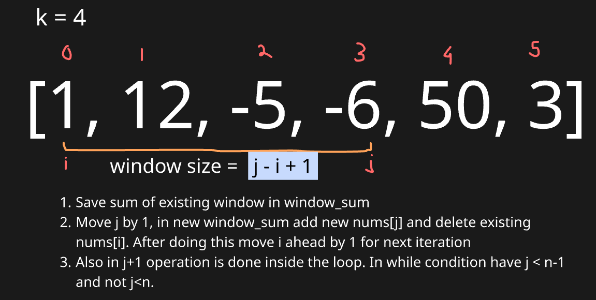

# Equivalent to finding subarray with maximum sum with size K
class Solution:
def findMaxAverage(self, nums: List[int], k: int) -> float:
n = len(nums)

# Step 1: Initialize window [0 : k-1]
i, j = 0, k - 1 # i = left, j = right
window_sum = sum(nums[i:j+1])
max_sum = window_sum

# Step 2: Slide window using while loop
while j < n - 1:
j += 1 # move right end forward
window_sum += nums[j] # add new element
window_sum -= nums[i] # remove old element
i += 1 # shift left end forward for next iteration
max_sum = max(max_sum, window_sum)

# Step 3: Return max average
return max_sum / k

Since it is fixed window to can only consider one right pointer, and left pointer will be i-k. This helps to make code look easier.
class Solution:
def findMaxAverage(self, nums: list[int], k: int) -> float:
arrSum = sum(nums[:k])
maxSum = arrSum

for i in range(k,len(nums)): #just considering right pointer
arrSum = arrSum + nums[i] - nums[i-k]
maxSum = max(maxSum, arrSum)

return maxSum/k

2. Maximum Number of Vowels in a Substring of Given Length

class Solution:
def maxVowels(self, s: str, k: int) -> int:
vowels = {'a','e','i','o','u'}
vCount = sum(1 for i in range(k) if s[i] in vowels)
maxVCount = vCount

for i in range(k,len(s)):
if s[i-k] in vowels:
vCount-=1
if s[i] in vowels:
vCount+=1
maxVCount = max(maxVCount, vCount)

return maxVCount

3. First Negative in every window of size k

class Solution:
def firstNegInt(self, arr, k):
n = len(arr)
i , j = 0, k-1

queue = [] #can even use deque to track negative
ans = []

# Step 1: Check for initial window
for x in range(k):
if arr[x]<0:
queue.append(arr[x])

ans.append(queue[0] if queue else 0)

# Step 2: Check for other windows
while j<n-1:
j+=1 #move j forward
if arr[j]<0:
queue.append(arr[j])

#perform work on existing ith element
#Step 3: Check if queue[0] element is to be removed from window
if queue and arr[i]==queue[0]:
queue.pop(0)

i+=1 #move i forward

#to check if negative exists, append
ans.append(queue[0] if queue else 0)

return ans
Standard Flow of solutions:
- Create initial window and get answer from it
- Check for other windows:
  - Increase end index
  - Add new element at end (jth element)
  - Remove the start element (ith element)
  - Try to consolidate the array formed in answer
  - Increase start index

Solution 2, solving as variable length window

class Solution:
def firstNegInt(self, arr, k):
i,j = 0,k-1
ans = []
n = len(arr)

while j<n:
while i<j and (j-i+1>k or arr[i]>=0):
i+=1
if arr[i]<0:
ans.append(arr[i])
else:
ans.append(0)

j+=1

return ans

- Sliding Window Maximum
Approach: Use a deque to track indices of potential maxima in the current window in decreasing order.
The front of the deque always represents the maximum of the current window.
Slide the window by adding the new element at the right and removing elements that are smaller or out of the window from the deque.

from collections import deque

class Solution:
def maxSlidingWindow(self, nums: List[int], k: int) -> List[int]:
n = len(nums)
dq = deque() # stores indices of useful elements (in decreasing order)
ans = []

i, j = 0, k - 1

# Step 1: Process the first window of size k
for idx in range(k):
while dq and nums[dq[-1]] < nums[idx]:
dq.pop()
dq.append(idx)
ans.append(nums[dq[0]]) # maximum of first window

# Step 2: Slide the window across the array
while j < n - 1:
j += 1 # expand window by moving right end

# Maintain decreasing order in deque
while dq and nums[dq[-1]] < nums[j]:
dq.pop()
dq.append(j)

# Remove element if it goes out of the window
if dq[0] == i:
dq.popleft()

ans.append(nums[dq[0]]) # max for current window
i += 1 # shrink window from left

return ans

- Initialize first window – Use deque to store indices in decreasing order of values for the first elements.
- Record first max – The front of the deque (dq[0]) holds the maximum of the first window.
- Slide window – Move the right end j forward and expand the window by one element.
- Maintain deque order – Pop indices from back if nums[j] is greater, ensuring deque stores potential maxima.
- Remove out-of-window elements & record max – Pop from front if index leaves window, then append nums[dq[0]] to results.
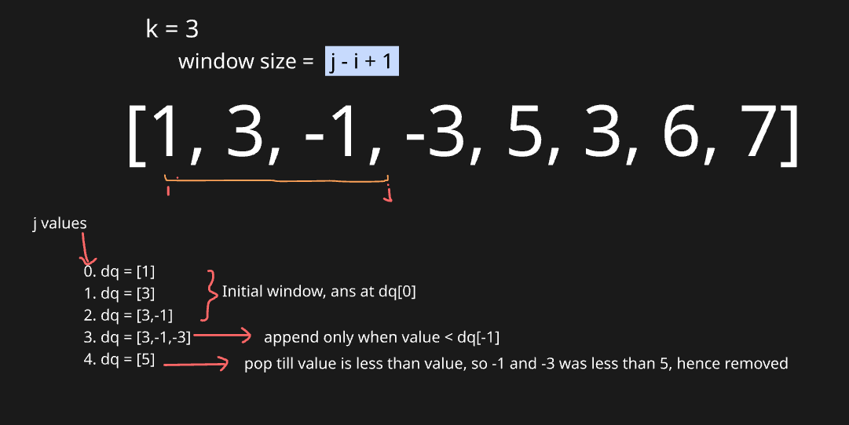

**Note** In all above codes, we are writing duplicate code for handling initial window. This can be taken cared in while loop itself with few code modificaitons

from collections import deque

class Solution:
def maxSlidingWindow(self, nums: List[int], k: int) -> List[int]:
n = len(nums)
dq = deque() # will store indices, not values
ans = []
i, j = 0, 0 # i = window start, j = window end

while j < n:
# Step 1: Maintain decreasing order in deque
while dq and nums[dq[-1]] < nums[j]:
dq.pop()
dq.append(j)

# Step 2: Remove elements that are out of the window
if dq[0] < i:
dq.popleft()

# Step 3: If window size reached k, record the maximum
if j - i + 1 == k:
ans.append(nums[dq[0]]) # front of deque = max in window
i += 1 # slide window start

j += 1 # always expand window

return ans

- Count Occurrences of Anagrams

from collections import defaultdict
d1 = defaultdict(int, {'a': 1, 'b': 2})
d2 = defaultdict(int, {'a': 1, 'b': 2, 'c': 0})

print(d1 == d2) # ❌ False

Even though c: 0 is basically what d1['c'] would come if accessed, Python doesn’t treat them as equal.

from collections import defaultdict
class Solution:

def search(self,pat, txt):

k = len(pat)
n = len(txt)
count = 0
i ,j = 0,k-1

dd_pat,dd_txt = defaultdict(int), defaultdict(int)

for v in pat:
dd_pat[v] += 1
for v in txt[:j+1]:
dd_txt[v] += 1

if dd_pat == dd_txt:
count+=1

while j<n-1:
j+=1
dd_txt[txt[j]] += 1 #add new element in dd
dd_txt[txt[i]] -= 1 #remove ith element in dd

flag=True #compare 2 default dicts
for v in dd_pat.keys():
if dd_pat[v]!=dd_txt[v]:
flag = False
break
if flag: count+=1

i+=1

return count

LEVEL 2:

- Longest Subarray with sum K
Here in place of giving window size we are given fixed condition: so it is variable length sliding window.
Approach: We use a sliding window with two pointers i and j. Expand j to grow the window sum, and whenever the sum exceeds k, shrink from i until it’s ≤ k. If the sum equals k, update the maximum length.
**Note**: It only works when elements are non-negative
Remember: length of window = j-i+1

def longestSubarrayWithSumK(arr: [int], k: int) -> int:
n = len(arr)
ans = 0
i = j = 0
s = 0

while j < n:
# expand window by including arr[j]
s += arr[j]

# shrink window until sum <= k
while s > k and i <= j:
s -= arr[i]
i += 1

# check if current window sum equals k
if s == k:
ans = max(ans, j - i + 1)

j += 1

return ans

- Max Consecutive Ones |||
Approach: We use a sliding window with two pointers (left and right).
Expand right to include elements, counting how many zeros are inside.
If the window has more than k zeros, shrink it from the left until valid again.
Track the maximum valid window length throughout the process.
class Solution:
def longestOnes(self, nums: List[int], k: int) -> int:
n = len(nums)
i,j=0,0
zc=0 #zeros count in window
ans=0 #stores max length

while j<n:
if nums[j]==0: #always expand window from right
zc+=1

while zc>k and i<=j: #shrink window till zero count < k
if nums[i]==0:
zc-=1
i+=1

ans = max(ans,j-i+1) #always check for max length window
j+=1

return ans

- Longest substring without repeating characters
- Use two pointers i and j to maintain a sliding window over the string.
- Track character frequencies within the window using a defaultdict(int).
- If a character’s count exceeds 1, move i forward while decrementing counts to remove duplicates.
- Update ans with the maximum window size j - i + 1 whenever the window is valid.
from collections import defaultdict
class Solution:
def lengthOfLongestSubstring(self, s: str) -> int:
n = len(s)
i,j = 0,0
dd = defaultdict(int)
ans = 0

while j<n:
val = s[j]
dd[val] += 1

while i<=j and dd[val]>1:
dd[s[i]]-=1
i+=1

ans = max(ans,j-i+1)
j+=1
return ans

Using Set:
class Solution:
def lengthOfLongestSubstring(self, s: str) -> int:
i,j = 0,0
ans = 0
check_ele = set()
while j<len(s):
letter = s[j]
if letter in check_ele:
while i<j and letter in check_ele:
check_ele.remove(s[i])
i+=1
check_ele.add(letter)
ans = max(ans,j-i+1)
j+=1
return ans

- Longest Repeating Character Replacement
Approach: A hashmap tracks the frequency of characters within the current window. If the condition (window size - max frequency) > k becomes true, it means more than k replacements are needed, so the window is shrunk from the left by moving i. Throughout this process, the maximum valid window length is updated and returned as the result.

from collections import defaultdict
class Solution:
def characterReplacement(self, s: str, k: int) -> int:
n=len(s)
i,j = 0,0
dd = defaultdict(int)
ans = 0

while j<n:
dd[s[j]] += 1

#max(count.values()) this will find the maximum frequency of a character in the hash again
while j - i + 1 - max(dd.values()) > k:
dd[s[i]] -= 1
i += 1
ans = max(ans, j - i + 1)
j+=1
return ans

Dry Run:
s = "AABAB", k = 1
i=0, j=0, dd={}, ans=0
- j=0 'A' → dd={'A':1}, 1-1=0≤1 → ans=1
- j=1 'A' → dd={'A':2}, 2-2=0≤1 → ans=2
- j=2 'B' → dd={'A':2,'B':1}, 3-2=1≤1 → ans=3
- j=3 'A' → dd={'A':3,'B':1}, 4-3=1≤1 → ans=4
- j=4 'B' → dd={'A':3,'B':2}, 5-3=2>1 → shrink i=1, dd={'A':2,'B':2}, ans=4
Result: 4 (max window length)

- Fruit Into Baskets
Approach: Two pointers i and j define the window, and a hash map tracks the count of each fruit type inside it. As new fruits are added from the right, if the number of distinct fruit types exceeds two, the left pointer i moves forward while decreasing counts and removing any fruit whose count becomes zero. Throughout this process, the maximum window length is updated and returned as the result.

#Problem is equivalent to: find length of longest subsequence having atmost 2 type of numbers
from collections import defaultdict

class Solution:
def totalFruit(self, fruits: List[int]) -> int:
n = len(fruits)
i,j=0,0
dd = defaultdict(int) #{fruit: it's count}
ans=0

while(j<n):
dd[fruits[j]] +=1
while len(dd.keys())>2:
dd[fruits[i]]-=1
#remove element from left whose count becomes 0 first on traversing left to right
if dd[fruits[i]]==0:
del dd[fruits[i]]
i+=1

ans = max(ans,j-i+1)
j+=1
return ans

better way:
class Solution:
def totalFruit(self, fruits: List[int]) -> int:
start = 0
max_len = 0
fruits_count = defaultdict(int)

for end in range(len(fruits)):
fruits_count[fruits[end]] += 1

while len(fruits_count) > 2:
fruits_count[fruits[start]] -= 1
if fruits_count[fruits[start]] == 0:
del fruits_count[fruits[start]]
start += 1

max_len = max(max_len, end - start + 1)

return max_len

